REG NO: 22TD0005 NAME: AKSHAYA S YEAR/SEM/SEC: Y3/S6/B

MINI PROJECT

HOTEL MANAGEMENT SYSTEM

DESCRIPTION:

A Hotel Management System (HMS) is a comprehensive software solution designed to streamline and automate the operations of a hotel or hospitality business. It serves as a central platform to manage various aspects of hotel operations, from reservations and guest services to financial transactions and reporting..A Hotel Management System is essential for efficient and organized hotel operations. It helps improve guest experiences, streamline internal processes, and drive revenue. The specific features and capabilities can vary depending on the software provider and the needs of the hotel or hospitality business.

REQUIREMENT ANALYSIS:

Preliminary Requirements Analysis:

- Database:

  - To store reservation detail.

  - To store guest detail.

  - To store payment detail.

  - To store rooms information.

- Web Interface:

  - Allow the reception to modify, add or delete reservation.

  - Allow the reception to modify, add or delete guest detail. iii).Allow the reception to provide the guest with the payment detail. PROCEDURE:
STEP 1: Database Design: Design a database to store information about rooms, guests, reservations, and other relevant data.
STEP 2: User Interface: Create a user-friendly interface with Windows Forms, including forms for room booking, guest check-in, and check-out.
STEP 3: Implement features to manage rooms, such as adding, editing, and deleting room details.
STEP 4: Develop functionality to manage guest information, including check-in and check-out processes.
STEP 5: Create a reservation system to allow guests to book rooms in advance.

STEP 6: Implement billing and payment features, including generating invoices and processing payments.
STEP 7: Develop reporting features for generating various reports like occupancy, revenue, and guest lists.
STEP 8: Ensure data security by implementing user authentication and authorization to restrict access to certain features.
STEP 9: Validate user input to prevent errors and ensure data integrity.

STEP 10: Implement error handling mechanisms to gracefully handle unexpected issues and provide informative error messages to users.

DATA FLOW DIAGRAM (DFD):
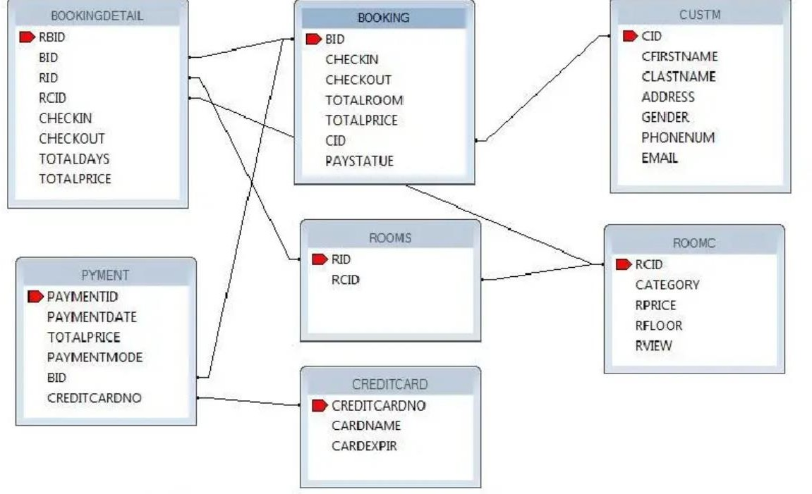

SAMPLE CODING:

THE CODE FOR THE TEXT BOX:
<asp:TextBox ID="TextBox5" runat="server">

CONNECTION BETWEEN THE WEB AND THE DATABASE:
Dim Conn As New OleDbConnection( "Provider=OraOLEDB.Oracle.1;Data Source=localhost:UserID=HR:Password-amanigeama;Unicode=True")

INSERTION FROM THE WEB INTO DATABASE:
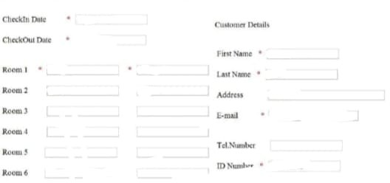

Dim Conn As New OleDbConnection( "Provider=OraOLEDB.Oracle.1;Data Source=localhost; UserID=HR:Password-amanigeama;Unicode=True")
Dim MyCmd As New OleDbCommand Conn.Open()
Dim InsertCommand As New OleDbCommand Dim CMD As New OleDbCommand CMD.Connection = Conn CMD.CommandType = CommandType.Text
CMD.CommandText = "SELECT RCID FROM RoomC WHERE RCID = "" &
TextBox2.Text & ""
Dim reader As OleDbDataReader reader = CMD.ExecuteReader
If reader.Read Then InsertCommand.Connection = Conn
InsertCommand.CommandType = CommandType.Text
InsertCommand.CommandText = "INSERT INTO RoomS(RID,RCID) VALUES(?,?)"

InsertCommand.Parameters.Clear() InsertCommand.Parameters.AddWithValue( "?". TextBox1.Text) InsertCommand.Parameters.AddWithValue("?". TextBox2.Text) InsertCommand.ExecuteNonQuery()
InsertCommand.Dispose() Conn.Close()
MsgBox("OK". MsgBoxStyle.Information) Elself Not reader.Read Then
MsgBox(" The room category not exist in Room Category table", MsgBoxStyle.Information)
End If
DELETING FROM THE DATABASE BY USING THE WEB:
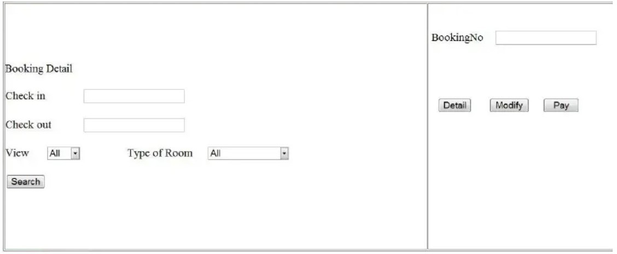

Dim Conn As New OleDbConnection( "Provider=OraOLEDB.Oracle. 1;Data Source=localhost:UserID=HR:Password=amanigeama:Unicode=True")
Conn.Open()
Dim DeleteCommand As New OleDbCommand DeleteCommand.Connection = Conn
Dim CMD As New OleDbCommand CMD.Connection = Conn CMD.CommandType = CommandType.Text

CMD.CommandText = "SELECT RID FROM RoomS WHERE RID="" &
TextBox1.Text &""
Dim reader As OleDbDataReader reader CMD.ExecuteReader
If reader.Read Then
DeleteCommand.CommandType = CommandType.Text DeleteCommand.CommandText = "DELETE FROM RoomS WHERE RID=?" DeleteCommand.Parameters.Clear() DeleteCommand.Parameters.AddWithValue( "?", TextBox1.Text) DeleteCommand.ExecuteNonQuery()
DeleteCommand.Dispose() End If
UPDATING THE DATA:


Dim Conn As New OleDbConnection( "Provider=OraOLEDB.Oracle. 1;Data Source=localhost;UserID=HR:Password=amanigeama:Unicode=True")
Conn.Open()
Dim UpdateCommand As New OleDbCommand UpdateCommand.Connection Conn
Dim CMD As New OleDbCommand CMD.Connection = Conn

CMD.CommandType = CommandType.Text
CMD.CommandText = "SELECT RCID FROM RoomC WHERE RCID = " &
TextBox2.Text & ""
Dim reader As OleDbDataReader reader CMD.ExecuteReader
If reader.Read Then
UpdateCommand.CommandType = CommandType.Text UpdateCommand.CommandText = "UPDATE RoomS set RCID=? WHERE
RID =?"
UpdateCommand.Parameters.Clear() UpdateCommand.Parameters.AddWithValue( "?". TextBox2.Text) UpdateCommand.Parameters.AddWithValue( "?", TextBox1.Text) UpdateCommand.ExecuteNonQuery()
UpdateCommand.Dispose() Conn.Close()
MsgBox(" OK", MsgBoxStyle.Information) Elself Not reader. Read Then
MsgBox(" The room category does not exist in Room Category table ". MsgBoxStyle.Information)
End If

ADDING THE CALENDAR EXTENSION:

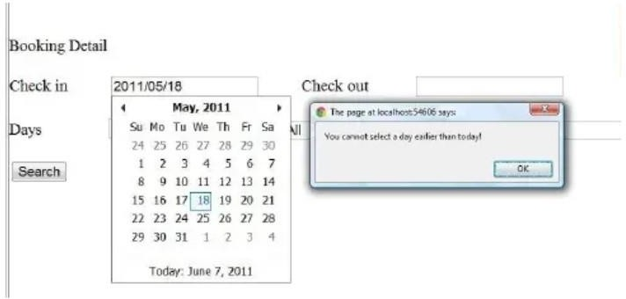

For Adding calendar extender, the toolkitScriptManager has to be added. Then the colander drags from the Ajax toolbox:
<asp:ToolkitScriptManager ID="ToolkitScriptManager1" runat="server">
</asp:ToolkitScriptManager>
<asp:TextBox ID="txtStartDate" runat="server"></asp:TextBox>
<asp:CalendarExtender ID="CalendarExtender1" TargetControlID="txtStartDate"
runat="server" Format="yyyy/MM/dd" OnClientDateSelectionChanged = "checkDate" />
TRANSFER VALUE FORM PAGE TO ANOTHER PAGE:
Session("field88") = txtStartDate.Text Session("field99") = TextEndDate.Text

SEARCH CODE:
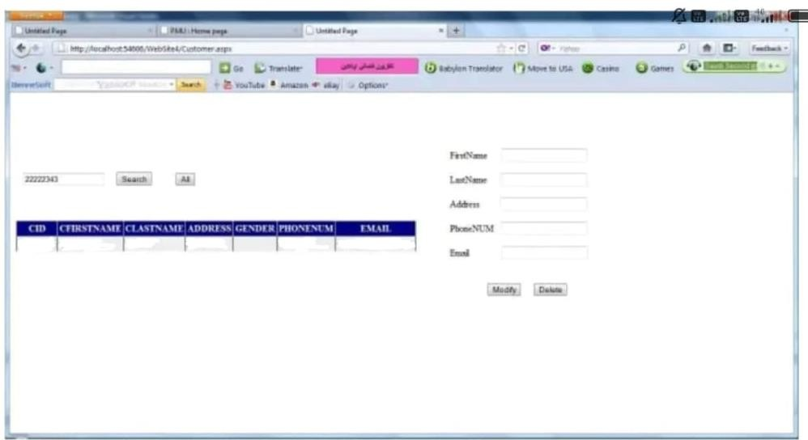
Dim Conn As New OleDbConnection("Provider=OraOLEDB.Oracle.1;Data Source=localhost; UserID=HR;Password=amanigeama;Unicode=True")
Dim MyCmd As New OleDbCommand Dim myDataSet As New DataSet myDataSet.Clear()
Conn.Open() MyCmd.Connection = Conn
MyCmd.CommandType = CommandType.Text Dim currentDate As Date
currentDate = System.DateTime.Now
If txtStartDate.Text < TextEndDate.Text Then
If System.DateTime.Now < txtStartDate.Text Or System.DateTime.Now < TextEndDate.Text Then
If DropDownList2.Items(0).Selected = True Then If DropDownList1.Items(0).Selected = True Then

MyCmd.CommandText = "Select RS.rid, RC.RCID, RC.Category, RC.Rprice, RC.RFloor, RC.Rview FROM RoomC RC, RoomS RS WHERE RC.RCID = RS.RCID AND RS.rid NOT IN (SELECT RS.rid FROM RoomC
RC, BOOKINGDETAIL BD WHERE ("" & txtStartDate.Text & " <= BD.CheckIn AND "" & TextEndDate.Text \&">=BD. CheckOut )AND RS.rid=BD.rid)"
Elself DropDownList1.Items(2).Selected = True Then
MyCmd.CommandText = "Select RS.rid, RC.RCID, RC.Category, RC.Rprice, RC.RFloor, RC.Rview FROM RoomC RC, RoomS RS WHERE RC.RCID =
RS.RCID AND RC.category="" & DropDownListl.Items(2).Value & "" AND RS.rid NOT IN (SELECT RS.rid FROM RoomC RC, BOOKINGDETAIL BD WHERE (""
& txtStartDate.Text & "<= BD.CheckIn AND " & TextEndDate.Text & ""
>=BD.CheckOut) AND RS.rid = BD.rid)"
Elself DropDownList1.Items(3).Selected= True Then
MyCmd.CommandText = "Select RS.rid, RC.RCID, RC.Category, RC.Rprice, RC.RFloor, RC.Rview FROM RoomC RC, RoomS RS WHERE RC.RCID =
RS.RCID AND RC.category="" & DropDownList1.Items(3).Value & "" AND RS.rid NOT IN (SELECT RS.rid FROM RoomC RC, BOOKINGDETAIL BD WHERE (""
& txtStartDate.Text &… End If
Elself DropDownList2.Items(1).Selected= True Then If DropDownList1.Items(0).Selected = True Then
MyCmd.CommandText = "Select RS.rid, RC.RCID, RC.Category, RC.Rprice, RC.RFloor, RC.Rview FROM RoomC RC, RoomS RS WHERE RC.RCID =
RS.RCID AND RC.Rview="" & DropDownList2.Items(1).Value &" AND RS.rid NOT IN (SELECT RS.rid FROM RoomC RC, BOOKINGDETAIL BD WHERE (""
& txtStartDate. Text & "<= BD.CheckIn AND "" & TextEndDate.Text & ">= BD.CheckOut) AND RS.rid=BD.rid)"
Elself DropDownList1.Items(1).Selected = True Then
MyCmd.CommandText = "Select RS.rid, RC.RCID, RC.Category, RC.Rprice, RC.RFloor, RC.Rview FROM RoomC RC, RoomS RS WHERE RC.RCID =
RS.RCID AND RC.Rview="" & DropDownList2.Items(1).Value & ""AND RC.category="" & DropDownList 1.Items(1).Value & …
NOT IN (SELECT RS.rid FROM RoomC RC, BOOKINGDETAIL BD WHERE (&
txtStartDate.Text & "<= BD.CheckIn AND " & TextEndDate.Text & ">= BD.CheckOut) AND RS.rid= BD.rid)"

Elself DropDownList1.Items(4). Selected = True Then
MyCmd.CommandText = "Select RS.rid, RC.RCID, RC.Category, RC.Rprice, RC.RFloor, RC.Rview FROM RoomC RC, RoomS RS WHERE RC.RCID =
RS.RCID AND RC.Rview="" & DropDownList2.Items(1).Value & "" AND RC.category="" & DropDownList1.Items(4).Value & "" AND RS.rid NOT IN (SELECT RS.rid FROM RoomC RC, BOOKINGDETAIL BD WHERE ("" &
txtStartDate.Text & "" <= BD.CheckIn AND "" & TextEndDate.Text & ">= BD.CheckOut) AND RS.rid = BD.rid)"
Elself DropDownList1.Items(5).Selected = True Then
MyCmd.CommandText = "Select RS.rid, RC.RCID, RC.Category, RC.Rprice, RC.RFloor, RC.Rview FROM RoomC RC, RoomS RS WHERE RC.RCID =
RS.RCID AND RC.Rview = "" & DropDownList2.Items(2).Value & "AND RC.category=" & DropDownList1.Items(1).Value & "" AND RS.rid NOT IN (SELECT RS.rid FROM RoomC RC, BOOKINGDETAIL BD WHERE ("" &
txtStartDate. Text & " <= BD.CheckIn AN D^ prime prime prime & TextEndDate.Text & ">= BD.CheckOut) AND RS.rid = BD.rid)"
Elself DropDownList1.Items(2).Selected = True Then
MyCmd.CommandText = "Select RS.rid, RC.RCID, RC.Category, RC.Rprice, RC.RFloor, RC.Rview FROM RoomC RC, RoomS RS WHERE RC.RCID =
RS.RCID AND RC.Rview = " & DropDownList2.Items(2).Value & " AND RC.category=" & DropDownList1.Items(5).Value & "" AND RS.rid NOT IN (SELECT RS.rid FROM RoomC RC, BOOKINGDETAIL BD WHERE (&
txtStartDate.Text & " <= BD.CheckIn AN D^ prime prime prime TextEndDate.Text & ">= BD.CheckOut) AND RS.rid = BD.rid)"
End If End If
MyCmd.Parameters.Clear() MyCmd.Parameters.AddWithValue( "?", txtStartDate.Text) MyCmd.Parameters.AddWithValue( "?". TextEndDate.Text)
Dim adapter As New OleDb.OleDbDataAdapter(MyCmd.CommandText, Conn) adapter.Fill(myDataSet. "0")
GridView1.DataSource = myDataSet.Tables("0") GridView1.DataBind()
Else

MsgBox(" you have chose a previous data") End If
Else
MsgBox(" the checkin data is bigger than the check out date") End If
Conn.Close()
LOGIN CODE:

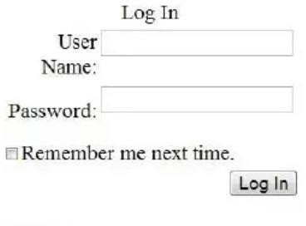

<LoggedInTemplate>
<span class="input">You are logged in. Welcome </span>
<asp:LoginName ID="LoginName1" runat="server" />
</LoggedInTemplate>
<AnonymousTemplate>
You are not logged in. Click the Login link to sign in.
<asp:Button ID="button7" runat="server" onclick="button7_Click" Text="Reminder" />

</AnonymousTemplate>
</asp:LoginView>
<br />
<asp:LoginStatus ID="LoginStatus 1" runat="server" />
CHECKING EXIT OF THE CUSTOMER ID CODE:
Using reader to check if the customer ID is exit or not, before doing insert to the Guest detail.
Dim CMD As New OleDbCommand CMD.Connection = Conn
CMD. Comman * dType =CommandType.Text
CMD. Comman * dText ="SELEC rceil CID FROM CUSTM WHERE CID = "" & TextBox7.Text &
Dim reader As OleDbDataReader reader = CMD.ExecuteReader
'INSERT INTO THE CUSTOMER TABLE
If Not reader.Read Then
'INSERT INTO CUTOMER TABLE
Dim InsertCUST As New OleDbCommand InsertCUST.Connection = Conn InsertCUST.CommandType = CommandType.Text
InsertCUST.CommandText = "INSERT INTO CUSTM(CID,CFirstName,CLastName, Address, PhoneNUM,Email)
VALUES(?.?.?.?.?.?)"
InsertCUST.Parameters.Clear() InsertCUST.Parameters.AddWithValue( "?". TextBox7.Text) InsertCUST.Parameters.AddWithValue( "?". TextBox2.Text) InsertCUST.Parameters.AddWithValue( "?". TextBox3.Text) InsertCUST.Parameters.AddWithValue( "?". TextBox4.Text)

InsertCUST.Parameters.AddWithValue( "?". TextBox6.Text) InsertCUST.Parameters.AddWithValue( "?". TextBox5.Text) InsertCUST.ExecuteNonQuery()
InsertCUST.Dispose()
End If reader.Close()
MsgBox(" OK", MsgBoxStyle. Information)
CALCULATING THE TOTAL COST:
Dim day As Int32 Dim chi As Date Dim cho As Date Dim price As Int16 price = 0
chi = CheckIn.Text cho = Checkout.Text
day = Date Diff(DateInterval.Day, chi, cho) Dim RomPrice As New OleDbCommand RomPrice.Connection = Conn
RomPrice.CommandType = CommandType.Text
RomPrice.CommandText = "SELECT Rprice from RoomC WHERE RCID="" & TextBox 19.Text & ""
Dim Room As New OleDb.OleDbDataAdapter(RomPrice.CommandText, Conn) Room.Fill(myDataSet. "RI")
price= myDataSet .Tables(^ prime prime R1^ prime prime ).Rows(0).Item(^ prime prime Rprice^ prime prime )
price = price* day myDataSet.Clear()

OUTPUT: RESERVATION FORM:
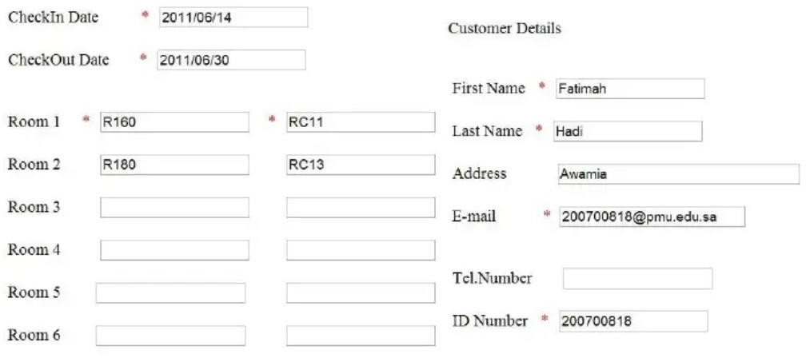

CHECKING INSERTED DATE:



SEARCH RESULT:
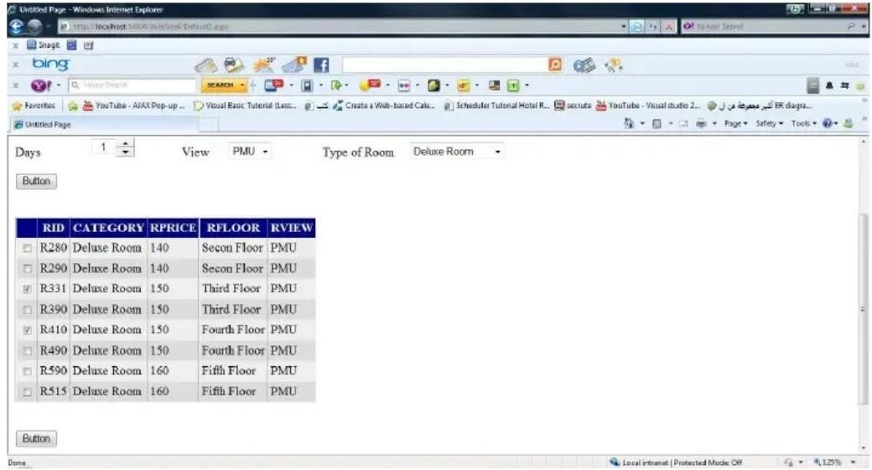
ADDING CALENDAR:
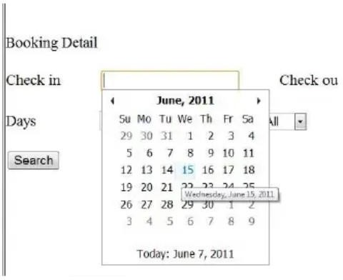

CREDIT CARD FORM:
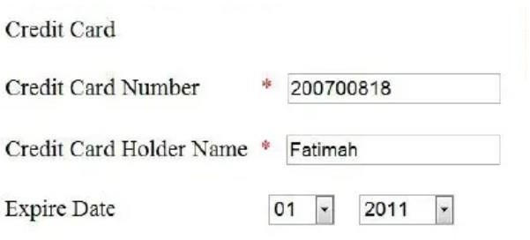

CALCULATING TOTAL COST:
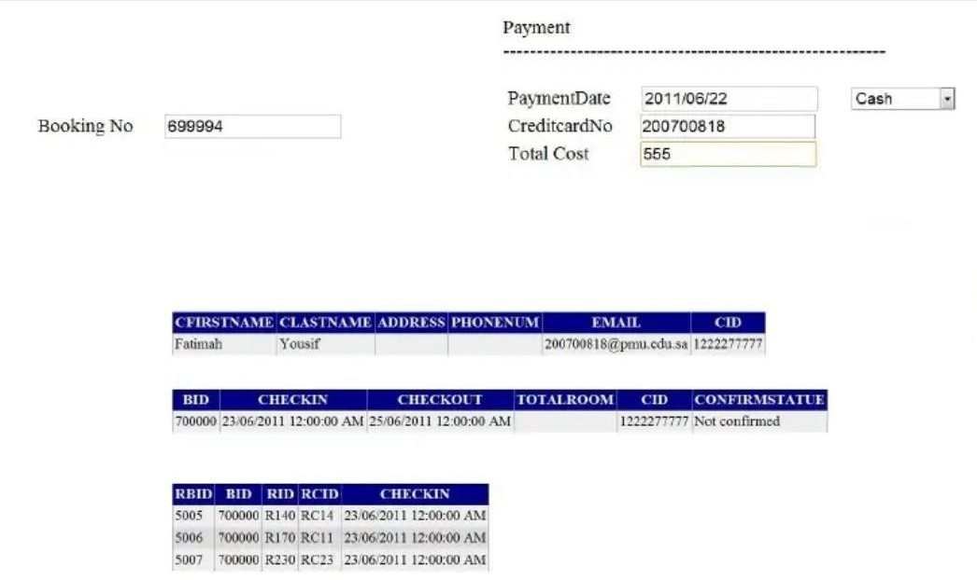

SEARCHING THE DETAILS OF THE GUEST:
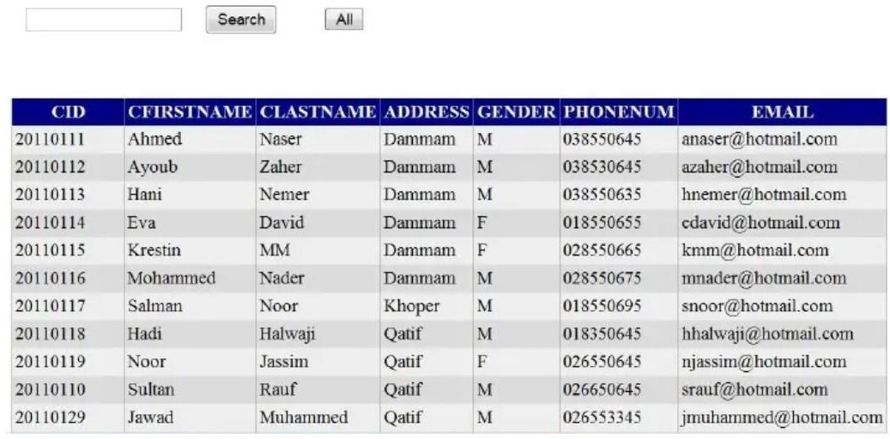

LOGIN SUCCESSFUL:
